Agiloft Contract Assistant Installation Walkthrough – O365
The installation method detailed in this document will allow you to install the ACA for multiple users at one time. To complete this installation, you will require:
- Admin access to your company's O365 account
- A configured manifest.xml file. For more information, visit either the Configuring the ACA for Word or Configuring the ACA for Outlook wiki page.

O365 Group Installation Process
- In the admin center, go to the Settings > Add-ins page. If you don't see the Add-in Page, go to the Settings > Integrated apps > Add-ins page. Alternatively, you can access the correct page by clicking here.
- Click Deploy Add-In.
- A bit of information about deploying a new add-in appears. Scroll down and click Next.
- Click Upload custom apps.
.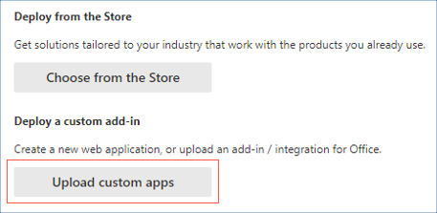
- Select I have the manifest file (.xml) on this device.
- Click Choose File. Find and select the proper manifest file. 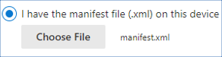
- Click Upload.
- You can now choose which users will gain access to the add-in. If this is the initial installation process for your company, you likely want to test the add-in amongst a specialized group of users before giving widespread access. To do so, select either Just Me or Specific users / groups. If you select Specific users / groups, add information for those parties, such as "Sales Team." If you plan on testing it yourself, enter your own credentials.
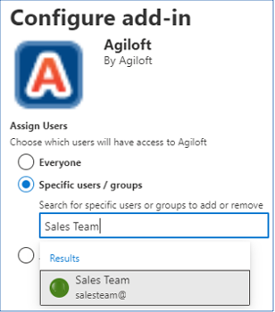
- Click Deploy. You will be directed to a page that indicates your add-in has been deployed. Do not close this window.
- Open either Microsoft Word or Outlook, depending on which ACA you are installing. The large A icon should appear on the right side of the ribbon for all users who were selected in step 8. If the add-in does not appear, relaunch Office.
- Open the ACA and test it to make sure it works properly, or reach out to the specific group/user you selected in step 8 and ask them to test it. To test the ACA, visit either the Using the ACA for Word or Using the ACA for Outlook wiki page.
- After you've verified that the ACA works as expected, you can give wider access to the users and groups that require it. Return to the window from step 9, select Next, and then select Change who has access to add-in to add more users.
- Announce to the users/groups you've added that the ACA is available and ensure that it is visible for all parties. If the add-in does not appear for any users, suggest that they relaunch Office.

For more information about deploying the ACA, visit the following Microsoft pages:
- Deploying Add-Ins in the Admin Center
- Centralized Deployment.

