Using the Vendor Portal of the Agiloft System
If you have been provided with a login to the Contract Management system, you will be using that login to upload documents upon request.
The system can be used to upload insurance certificates, performance bonds, your W-9, and performance reports, to manage your own contact and company information, and to view your contracts.
This guide provides you with some instructions on how to use the system.
When you login, you will come to the main welcome screen:
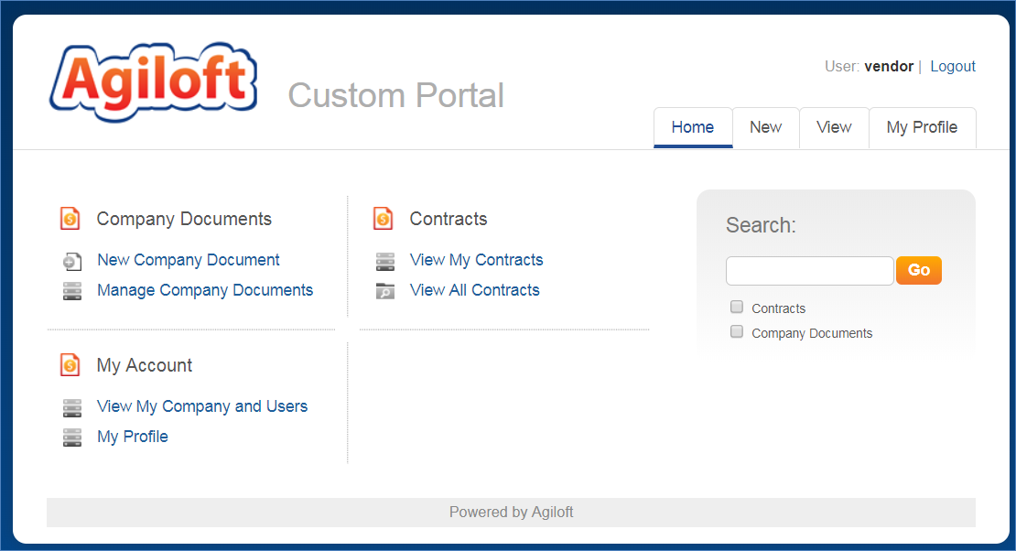

From here, you can upload new company documents, view your existing documents, manage your company and your own profile, and view contracts.

Uploading a W-9 Form
Click on the New Company Document link in the menu above. The following screen appears with a dropdown:
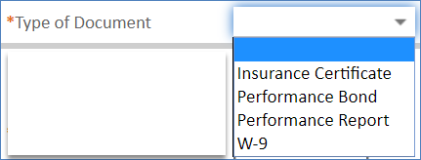

Select W-9.
Then drag and drop your file from your file explorer onto the box labeled: “Drag&Drop files next to the Upload File label:

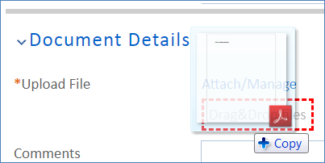

Or if you can’t get your file explorer window in a position to do this, you can alternatively click the Attach/Manage link and then the Attach File(s) button to open up a browse window:
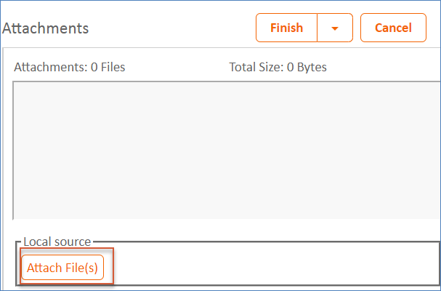

Locate your file, double-click to attach it, and then click the Finish button:
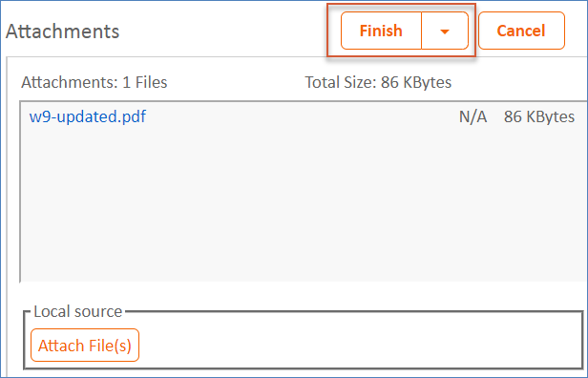

Then save the record by clicking the Save button:
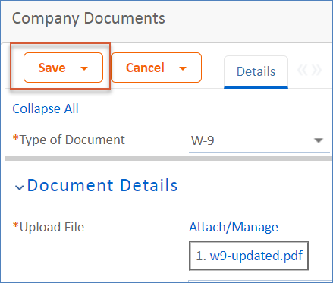

Uploading Insurance Certificates
You may also use the system to upload your insurance certificates and to identify their expiration date, coverage types, and so on. You can also upload new certificates when the old ones expire.
To start the process, click on the New Company Document link from the home page, and then choose Insurance Certificate as the type of document:
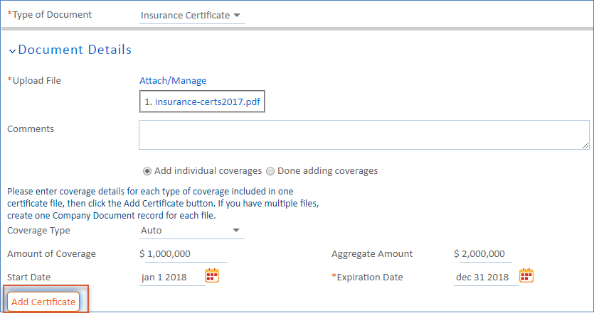
This will cause some additional fields to appear. Upload the certificate file using the same method as described above for W-9’s.
Then you will fill in the set of details for each coverage type on the certificate, one at a time, clicking the Add Certificate button to add each one:
As you click the button, the line item will appear in the table below and you can update the same fields for the next coverage type:

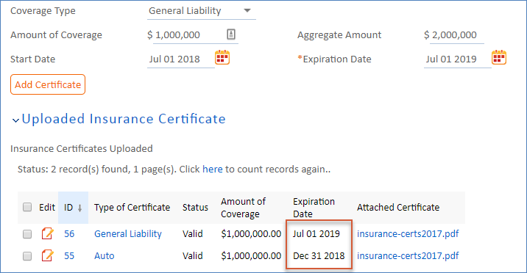

Note that you can include coverages that have different expiration dates.
You can modify the detail fields for each coverage type with its coverage amounts and click the Add Certificate button again to add it to the list, until you have included all of the types of coverage included in the attached document.
Once you have added all the coverage types, click the Done adding coverages radio button to hide the data entry fields, and then click the Save button to complete the company document record.
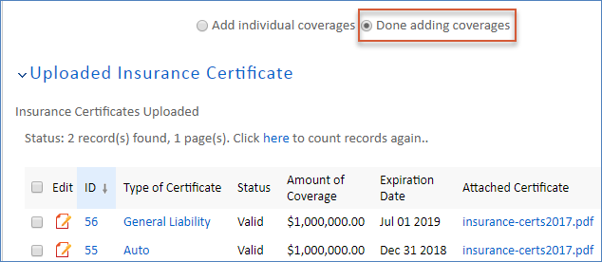
If you have multiple certificate documents to upload, then you should create a separate company document record for each of them.

Updating Expired Certificates
When your insurance certificates near expiration, you may receive an email reminding you that updated certificates are needed. When you receive new certificates from your insurer, just treat them like a new company document and follow the same process as described above to upload the new file and coverage types.

Viewing Your Company Documents
You can click the link to Manage Company Documents to view all of the files you have uploaded:
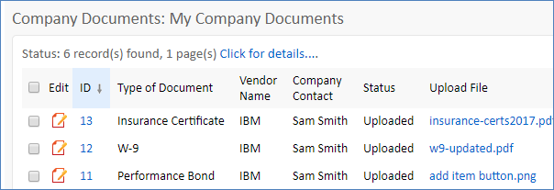

Updating Your Company Information
You can update information for your company, or add a new user from your company, by clicking the View My Company and Users link:
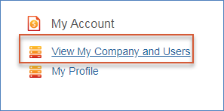
Click the Edit button on the page that appears to update your company telephone, fax or Website URL:
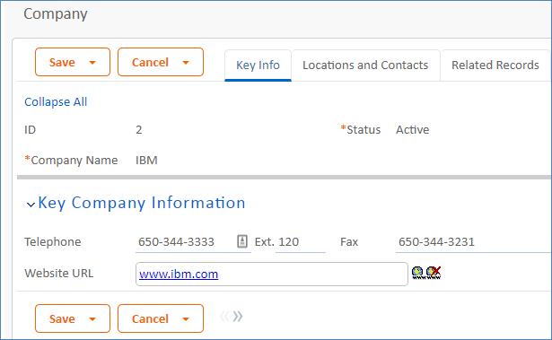
Click on the Locations and Contacts tab to update your company locations and add new users to the system.
Click the New button above the table to add a new record:
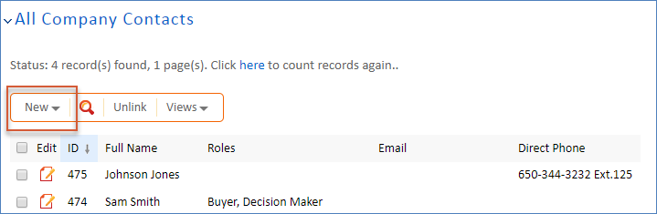

Updating your User Profile
You can change your own password and contact information by clicking the My Profile tab or link from the home page. That will bring up your user record:
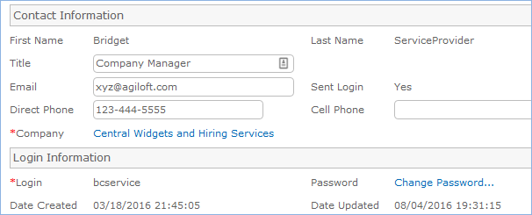

You can change your title, email, and phone information, and you can also change your password for the system.
If your company has multiple locations, you can also select your own location from the list.

Viewing Contracts
You can view contracts related to your company by using the links under the Contracts section of the home page.
There are two defined filters, one showing only contracts for which you are the main contact (View My Contracts) and another for all contracts for your company.
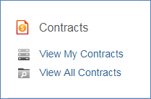

Searching
You can also use the search block to search through your company documents or contracts to find a record of interest. Just check the box for the item(s) you wish to search.
